Configuration Guide

Microsoft Dynamics® CRM Portal Authentication using Windows® Azure™ AppFabric Access Control Service (ACS)

Use this guide to learn about the steps required to configure the a Portal solution for Microsoft Dynamics CRM 2011 to use Windows Azure AppFabric Access Control Service (ACS) authentication.

Pre-Requisite Setup Steps
A Windows Azure platform subscription should be available which provides access to the Azure Management Portal. The ASP.NET portal can be hosted from Windows Azure Hosted Services or on-premises from an IIS 7.0 server running .Net Framework 4.0.

Configuring the Access Control Service
A Service Namespace is required to contain the authentication settings.
- Sign into the Azure Management Portal
- Browse over to the "Access Control" table
  - Bottom left: Click Service Bus, Access Control & Caching
  - Top Left: Click Access Control
- Select the subscription that contains the ACS namespace
- Click New to open the new ACS namespace dialog
- Specify an available namespace ensuring that "Access Control" service is selected
- Click Create Namespace

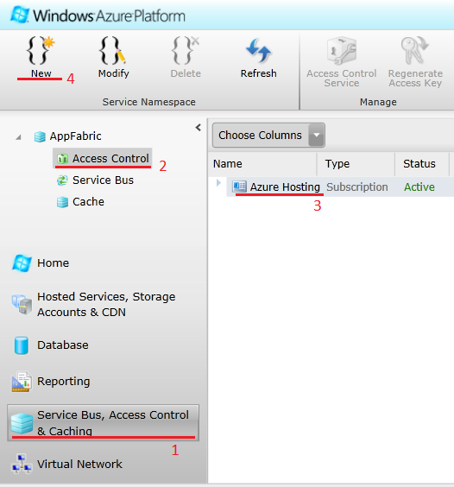
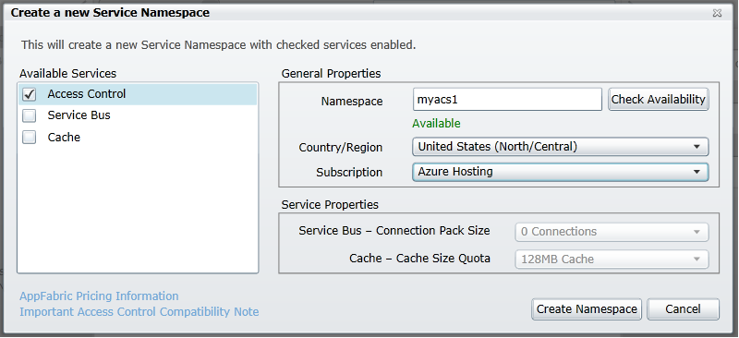

Open ACS Management Portal
- The new namespace should appear in the table
- Select the namespace
- Click the Access Control Service button to open the ACS Management Portal
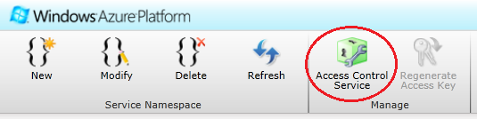

ACS Management Portal
The ACS based federated authentication settings are managed under this area of the portal. The two major steps to completing these settings are to select Identity Providers and specifying Relying Party Applications.

Adding Identity Providers
Identity providers decide which user accounts are available for authentication. By default, the Windows Live ID identity provider is available which allows authentication by Live ID users.
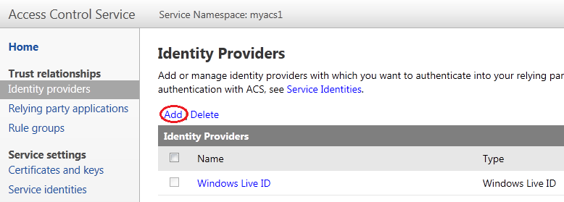
- Click the Add link to select a new identity provider
- Some providers only require a display name as a label for authenticating users
- Other providers require further credentials to be established between the identity provider and ACS. Refer to the Learn more links for details.
- Repeat this step for each identity provider you wish to make available

Add Relying Party Application
At least one relying party application must be setup for federated authentication to succeed. Navigate to the Relying Party applications area and click the "Add" link.
On the Add Relying Party Application page provide a display Name that identifies the relying party. Note that this name may also appear to the end user during sign-in depending on the implementation of the portal's sign-in page.
Under the Realm field, specify the domain URL of the portal. Examples of valid URLS include:
- http://localhost/
- http://localhost:8080/
- http://contoso.com/
- https://contoso.com/
Authentication against ACS will fail if the portal is not hosted from this URL. It is not necessary for the portal to be available to the Internet.
For the Return URL, specify the realm URL and append a path of /Federation.axd.
- http://localhost/Federation.axd
If you are hosting one of the sample portals, an error.html page is available that can be specified as the Error URL.
- http://localhost/error.html
For the Token format, specify SAML 2.0. The Token encryption policy can be set to None and the Token lifetime can be left at the default of 600 seconds.
Under the Identity Providers section, check the providers that are allowed to authenticate.
If this is the first relying party application, check the box to Create new rule group which creates a default rule group when saved. Subsequent relying party applications may share this default rule group rather than creating a new one.
Under the Token signing section, specify Use service namespace certificate (standard).
Click Save.
This step may be repeated to add more relying party applications. This enables a single sign-on experience between all the relying party portals.
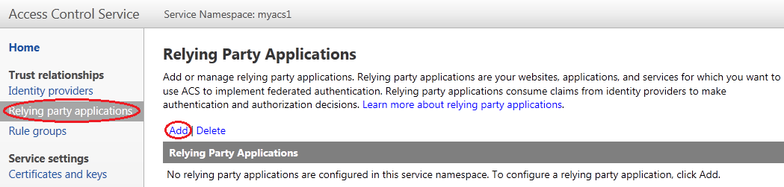

Generate Rules for the Rule Group
If a new rule group was created as a part adding a new relying party, then rules need to be created for the group. Navigate to the Rule Groups area and select the Default Rule Group.
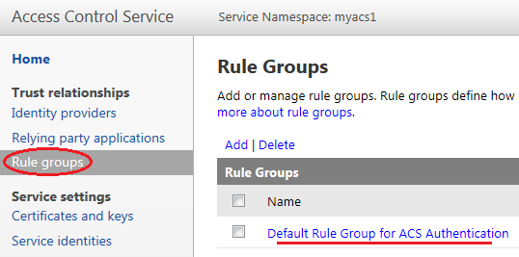
Click the Generate link to add the default rules.
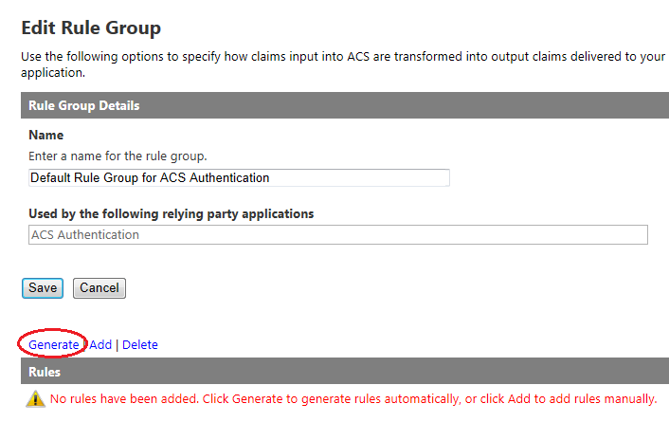
Finally, click the Generate button to create rules for every identity provider.
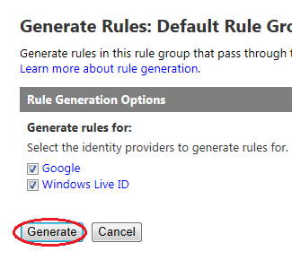

Gathering Portal Settings
At this point, the required ACS management settings are complete and several values need to be applied to the ASP.NET portal. Take note of the following settings:
- Record the Service Namespace value
- Under Trust relationships -> Relying Party application, open the relying party details, record the Realm URI
- Under Service settings -> Certificates and keys -> Token Signing, open the Service Namespace for the x.509 Certificate. Under the Certificate section, record the thumbprint
- Under Development -> Application integration -> Endpoint Reference, record the WS-Federation Metadata

Configuring the Portal
Portal configuration involves taking the values collected from the ACS Management Portal and applying them to the web.config file of the portal. The following is a condensed Web.config snippet highlighting how the above values are specified in the <microsoft.identityModel> configuration section:
<configuration>
<configSections>
<section name="microsoft.identityModel" type="Microsoft.IdentityModel.Configuration.MicrosoftIdentityModelSection, Microsoft.IdentityModel, Version=3.5.0.0, Culture=neutral, PublicKeyToken=31bf3856ad364e35"/>
</configSections>
<appSettings>
<add key="FederationMetadataLocation" value="[WS-Federation Metadata]s"/>
</appSettings>
<microsoft.identityModel>
<service>
<audienceUris>
<add value="[Realm URI]"/>
</audienceUris>
<federatedAuthentication>
<wsFederation passiveRedirectEnabled="false" issuer="https://[Service Namespace].accesscontrol.windows.net/v2/wsfederation" realm="[Realm URI]”
requireHttps="true"/>
<cookieHandler requireSsl="false"/>
</federatedAuthentication>
<issuerNameRegistry type="Microsoft.IdentityModel.Tokens.ConfigurationBasedIssuerNameRegistry, Microsoft.IdentityModel, Version=3.5.0.0, Culture=neutral, PublicKeyToken=31bf3856ad364e35">
<trustedIssuers>
<add thumbprint="[Thumbprint]" name="https://[Service Namespace].accesscontrol.windows.net/v2/wsfederation"/>
</trustedIssuers>
</issuerNameRegistry>
<certificateValidation certificateValidationMode="None"/>
</service>
</microsoft.identityModel>
</configuration>

Login Screen Verification
In a web browser, open the Realm URI to navigate to the deployed portal application. Click the Login link to open the portal's identity provider selection page. If the configuration is correct, a module should appear in the body of the page allowing the user to select from the configured identity providers.
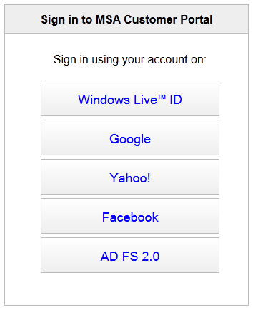

Windows Azure AppFabric ACS User Registration Scenarios
This guide covers the configuration and workflow of the various user registration scenarios available to Portals for Microsoft Dynamics CRM 2011. User registration is the process of mapping a federated user account provided by AppFabric ACS to a new or existing Microsoft Dynamics CRM 2011 contact entity. A contact is considered fully registered when an entity has a username value and has the "Logon Enabled" flag enabled. An unregistered user will have either or both fields empty or have no existing contact entity created.
All other fields of the contact are not required to allow a user to authenticate into the portal. However, the various Web Authentication fields are used to control the registration behavior for unregistered users.
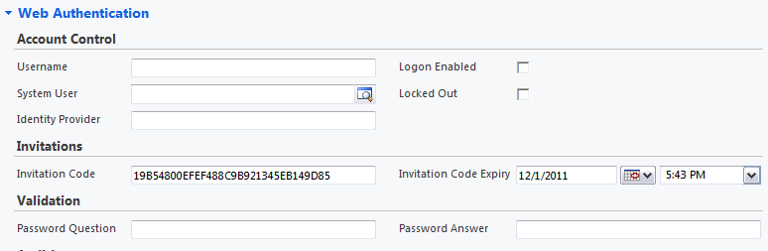

The Federation Authentication Handler (FAH)
The FAH is the entry/return point for all ACS sign-in responses directed to the portal. In the terminology of the Windows Identity Foundation (WIF), the AppFabric ACS plays the role of the identity provider while the portal is the relying party. The FAH is manifested by the /federation.axd endpoint. It makes decisions on if and how to register incoming users as well as authenticating users based on the configuration settings as well as the state of the existing contacts.
It carries out the same role as the (WS) Federation Authentication Module (FAM) but rather than being a module that watches over every request, it is a single endpoint handler.

Scenarios
The basic registration scenarios are:
- Invitation code
- Invitation code + Challenge Question/Answer
- Email confirmation
- Open registration

Configuration Settings
Configuration is done though the "microsoft.xrm.portal.identityModel/registration" node of the Web.config.
<configuration>
<configSections>
<section name="microsoft.xrm.portal.identityModel" type="Microsoft.Xrm.Portal.IdentityModel.Configuration.IdentityModelSection, Microsoft.Xrm.Portal"/>
</configSections>
<microsoft.xrm.portal.identityModel>
<registration enabled="true"
registrationPath="~/confirm-invite"
profilePath="~/profile"
accountTransferPath="~/login"
requiresInvitation="true"
requiresChallengeAnswer="true"
requiresConfirmation="true"
invitationCodeDuration="01:00:00"/>
</microsoft.xrm.portal.identityModel>
</configuration>

Settings
The available setting attributes are:
- enabled – Allows all user registration processing to be globally enabled or disabled.
  - Default: false
- requiresInvitation – Forces an invitation code to be provided before a user is registered.
  - Default: true
- requiresChallengeAnswer – Forces a challenge answer to be provided in addition to an invitation code before a user is registered.
  - Default: true
- requiresConfirmation – Enables an email workflow to be triggered to confirm that the registering user possesses a valid email address. Enabling this prevents open registration from occurring.
  - Default: true
- defaultReturnPath – The return path, used by the federation authentication handler, when no explicit path is provided
  - Default: ~/
- registrationPath – The path to the registration page that renders the form for providing invitation code, challenge question/answer, and open registration details. A user is redirected here if he or she is signing into the portal but is not yet registered. In this case, the sign-in attempt has either failed or is still in progress. If no value is provided, the user is redirected to the defaultReturnPath.
  - Default: null
  - Example: ~/register
- profilePath – The location the user is redirected to after a new contact registration is created. If a contact record is missing values for required fields and the requiredLevel attribute is set to the "ApplicationRequired" value, then the user is redirected to this page after every sign-in. This redirect indicates a successful registration or sign-in. If no value is provided, the user is redirected to the defaultReturnPath.
  - Default: null
  - Example: ~/profile
- confirmationPath – The location the user is redirected to after a email confirmation workflow is triggered to provide further instructions on completing the registration. If no value is provided, the user is redirected to the defaultReturnPath.
  - Default: null
  - Examples: ~/confirm, ~/register?result-code=confirm
- errorPath – The location the user is redirected to when the federation authentication handler throws an exception. If no value is provided, the user is redirected to the defaultReturnPath.
  - Default: null
  - Example: ~/error
- accountTransferPath – When the LiveIdAccountTransferHandler (rather than the default LiveIdWebAuthenticationHandler) is wired up as the Windows Live ID authentication sign-in response handler (LiveID.axd), users are redirected to this account transfer page. This page should prompt the user to continue to the next step of signing into an AppFabric ACS account.
  - Default: null (user is immediately redirected to the ACS home realm discovery page)
  - Example: ~/account-transfer
- unregisteredUserPath – When the LiveIdAccountTransferHandler is unable to find the Windows Live ID account that a user is attempting to transfer, the user is redirected to this path.
  - Default: ~/
  - Example: ~/register?result-code=unregistered
- requiredLevel – Controls the level of validation when determining if a contact entity contains all the attribute values deemed required. See also profilePath
  - Default: ApplicationRequired
  - Examples: ApplicationRequired, Recommended, None
- invitationCodeDuration – When a confirmation email workflow is generated, this value specifies the duration that the invitation code is considered valid. Specified as a TimeSpan.Parse string.
  - Default: null (never expires)
  - Example: 6.00:00:00 (six days)

Invitation Code
In this scenario, a contact entity is created with an invitation code specified but the username and logon enabled flag is left empty. The invitation code expiry may be optionally set. The password question and answer must be left empty (otherwise the user must register through the Challenge Question/Answer scenarios below). The invitation code may be sent to the user through email at which point the user is ready to register.
Scenario 1 – User directly provides invitation code through the registration form
- Open the /register page
  - Enter the provided invitation code
  - Click button to continue to sign-in
- Links to the ACS identity provider selection page
  - Click the link to an identity provider
- Links to the identity provide sign-in page
  - Enter credentials and click Sign-in
- sRedirected back to the portal 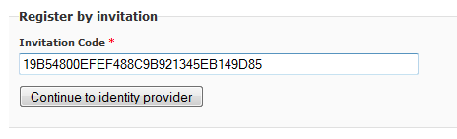
Scenario 2 – User directly provides invitation code through the federation authentication handler
- Enter the URL:
  - /federation.axd?invitation=1E5BB3D120BE4E1B888304FEECFC690B
- Redirected to the ACS identity provider selection page
  - Click the link to an identity provider
- Links to the identity provide sign-in page
  - Enter credentials and click Sign-in
Scenario 3 – User sign-in occurs prior to invitation code submission
- Open the /login page
  - Click the Sign-in link to go to the identity provider
- Links to the ACS identity provider selection page
  - Click the link to an identity provider
- Links to the identity provide sign-in page
  - Enter credentials and click Sign-in
- Redirected back to the portal /confirm-invite page
  - Enter the provided invitation code
  - Click button to submit

Invitation Code + Challenge Question/Answer
In this scenario, a contact entity is created with an invitation code specified but the username and logon enabled flag is left empty. The invitation code expiry may be optionally set. The invitation code is sent to the user through email. A value for the challenge password and answer must also be provided. The answer is a value that the user either implicitly possesses or is given through a channel separate from the invitation code delivery. If a user is missing a value for the challenge answer, the federation authentication handle will throw an exception and redirect to the error page.
Relevant Registration Settings
- requiresInvitation="true"
- requiresChallengeAnswer="true"s
Scenario 1 – User directly provides invitation code + challenge answer through the registration form
- Open the /confirm-invite page
  - Enter the provided invitation code
  - Click button to continue to sign-in
  - Since this code requires a challenge answer, a new field appears to accept the answer
  - Click button to continue to sign-in
- Links to the ACS identity provider selection page
  - Click the link to an identity provider
- Links to the identity provide sign-in page
  - Enter credentials and click Sign-in
Scenario 2 – User directly provides invitation code through the federation authentication handler
- Enter the URL:
  - /federation.axd?invitation= 62C77CEB02B64093801FBB9364634838&answer=Mr.%20Pet
- Redirected to the ACS identity provider selection page
  - Click the link to an identity provider
- Links to the identity provide sign-in page
  - Enter credentials and click Sign-ins
Scenario 3 – User sign-in occurs prior to invitation code submission
- Open the /login page
  - Click the Sign-in link to go to the identity provider
- Links to the ACS identity provider selection page
  - Click the link to an identity provider
- Links to the identity provide sign-in page
  - Enter credentials and click Sign-in
- Redirected back to the portal /confirm-invite page
  - Enter the provided invitation code
  - Click button to submit
  - Since this code requires a challenge answer, a new field appears to accept the answer
  - Click button to submit
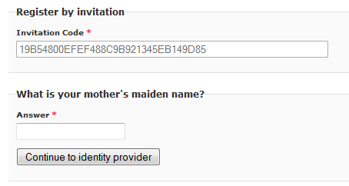

Email Confirmation
These scenarios do not require a contact entity to be created prior to user registration. The user initiates the registration by providing an email address to the portal. The portal creates a contact entity and generates an invitation code. The invitation code is sent to the user manually or through a workflow. At this point, the contact entity has a username and invitation code but the logon enabled flag remains disabled.
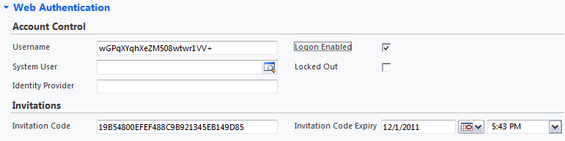
Relevant Registration Settings
- requiresInvitation="false"
- requiresChallengeAnswer="false"
- requiresConfirmation="true"
Scenario 1 – User sign-in prior to submitting email address
- Open the /login page
  - Click the Sign-in link to go to the identity provider
- Links to the ACS identity provider selection page
  - Click the link to an identity provider
- Links to the identity provide sign-in page
  - Enter credentials and click Sign-in
- Redirected back to the portal /confirm-invite page
  - Fill in the sign-up form providing an email
  - Click Sign-up
- Redirected to the /confirm-invite page
  - A contact entity is created in the CRM with a new invitation code and the provided email
  - A workflow is executed upon creation to send a message containing the invitation code to the email address
  - Use receives and opens the message
  - Enter the provided invitation code
  - Click button to submit
- Redirected to the portal
Scenario 2 – User submits email address prior to sign-in
- Open the /confirm-invite page
  - Fill in the sign-up form providing an email
  - Click button to continue to sign-in
- Links to the ACS identity provider selection page
  - Click the link to an identity provider
- Links to the identity provide sign-in page
  - Enter credentials and click Sign-in
- Redirected back to the portal /confirm-invite page
  - A contact entity is created in the CRM with a new invitation code and the provided email
  - A workflow is executed upon creation to send a message containing the invitation code to the email address
  - Use receives and opens the message
  - Enter the provided invitation code
  - Click button to submit
- Redirected to the portal
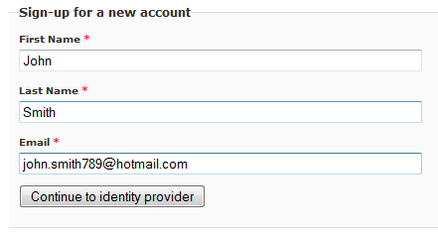

Open Registration
This scenario does not perform validation checks and allows all incoming user accounts to be automatically registered. A contact entity is created with the provided username and the logon enabled flag is enabled. If a display name and email address is provided by the identity provider, then the contact's last name and email are populated as well.
Scenario 1 – User sign-in omitting any profile values
- Open the /login page or redirected there after requesting a protected page
  - Click the Sign-in link to go to the identity provider
- Links to the ACS identity provider selection page
  - Click the link to an identity provider
- Links to the identity provide sign-in page
  - Enter credentials and click Sign-in
Scenario 2 – User submits profile values prior to sign-in
- Open the /confirm-invite page
  - Fill in the sign-up form
  - Click button to continue to sign-in
- Links to the ACS identity provider selection page
  - Click the link to an identity provider
- Links to the identity provide sign-in page
  - Enter credentials and click Sign-in
- Redirected back to the portal

Transferring Windows Live ID Account to Windows Azure AppFabric ACS Account
Portals that are migrating from standard Windows Live ID authentication to AppFabric ACS authentication will have contact entries that need to be transferred. There are two steps in enabling this feature:
- Replace the Live ID authentication handler with the account transfer handler using the following configuration transform:
<configuration xmlns:xdt="http://schemas.microsoft.com/XML-Document-Transform">
<system.web>
<httpHandlers>
<add xdt:Locator="Match(path)" xdt:Transform="Remove" path="LiveID.axd" />
<add xdt:Transform="Insert" path="LiveID.axd" verb="*" type="Microsoft.Xrm.Portal.IdentityModel.Web.Handlers.LiveIdAccountTransferHandler, Microsoft.Xrm.Portal"/>
</httpHandlers>
</system.web>
<system.webServer>
<handlers>
<add xdt:Locator="Match(name)" xdt:Transform="Remove" name="LiveId" />
<add xdt:Transform="Insert" name="LiveId" verb="*" path="LiveID.axd" preCondition="integratedMode" type="Microsoft.Xrm.Portal.IdentityModel.Web.Handlers.LiveIdAccountTransferHandler, Microsoft.Xrm.Portal"/>
</handlers>
</system.webServer>
</configuration>

At this point, users may no longer authenticate with their standard Live ID accounts and must complete the transfer process to sign-in with an ACS based account instead.
- Provide values for the accountTransferPath and unregisteredUserPath registration settings.
Scenario 1 – Transferring an account
- Open the /login page
  - Click the Live ID sign-in link
- Links directly to the Live ID sign-in page
  - Enter credentials and click Sign-in
- If the account is registered, redirected to the /login page (accountTransferPath)
  - User is prompted to sign into ACS account
  - Click the Sign-in link to go to the identity provider
- Links to the ACS identity provider selection page
  - Click the link to an identity provider
- Links to the identity provide sign-in page
  - Enter credentials and click Sign-in
- Redirected back to the portal at the / (home) page
  - User account is transferred
Scenario 2 – Live ID account is not registered
- Open the /login page
  - Click the Live ID sign-in link
- Links directly to the Live ID sign-in page
  - Enter credentials and click Sign-in
- If the account not registered, redirected to the /confirm-invite?result-code=unregistered page (unregisteredUserPath), and an error message is displayed

